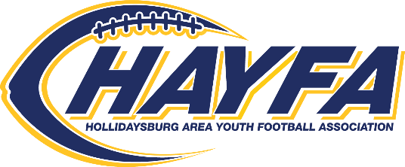2022 HAYFA GAME SCHEDULE

Team #1 - M&M Mavericks Team #3 – Lakemont Lake Monsters

Team #2 - Sheetz Stallions Team #4 - Holy Trinity Guardians

**(Home team is listed first and takes the Hollidaysburg home side of the field.)**

**WEEK DAY/DATE GAME #1 GAME #2**

SAT 8/20 HAYFA KICK-OFF SCRIMMAGE @ Tiger Stadium (all teams) 3:30 – 6:00 pm

|  |  |  |
| --- | --- | --- |
| 1 | SAT 8/27 1 – 2 @ 4:00 pm  16 oz. plastic jars Peanut Butter* | 3 – 4 @ 5:30 pm |
| 2 | SAT 9/10 2 – 4 @ 8:30 am  20 oz squeezable Grape Jelly* | 1 – 3 @ 10:00 am |
| 3 | SAT 9/17 4 – 1 @ 8:30 am  Canned tuna* | 3 – 2 @ 10:00 am |
| 4 | SAT 9/24 4 – 3 @ 8:30 am  Canned chicken* | 2 – 1 @ 10:00 am |
| 5 | SAT 10/1 3 – 1 @ 8:30 am  Canned noodles* | 4 – 2 @ 10:00 am |
| 6 | SAT 10/8 Canned soups* 2 – 3 @ 6:00 pm  Canned soups* | 1 – 4 @ 7:30 pm |
| SALUTE TO SERVICE GAME - Wear uniform reversed | | |

WED 10/26 FUTURE TIGER BOWL - Only for 6th Graders @ 6:00 pm





***\*This season HAYFA is partnering with the Tiger Pack Program.***

***Please help and bring items to your game. Thank You.***